**End User Experience Scorecard Reports**

With Goliath Performance Monitor 12.1.0, the End User Experience Scorecard reports were added to the product. You can use these scorecard to obtain objective data about the overall performance of your Citrix and Horizon environments.

**Scorecard Reports**

* Citrix XenApp End User Experience Scorecard
* Citrix XenDesktop End User Experience Scorecard
* Citrix XenApp Logon Duration Scorecard
* Citrix XenDesktop Logon Duration Scorecard
* VMware Horizon BLAST End User Experience Scorecard

Based on industry best-practices and displayed using a scale of 0-100 (where 100 is best), overall score and individual end user experience metric scores can be viewed quickly to understand which users may be experiencing issues over the selected time period.

Color-coded categories reveal bottlenecks in your environment enabling you to understand quickly what's causing end user experience issues.

**To Create a Scorecard Report**

1. Within the Goliath interface, go to the **Reports** page and click **New**.
2. Depending on the scorecard you would like to run, click in to the Citrix or Horizon section and select the report template from the list.  
     
   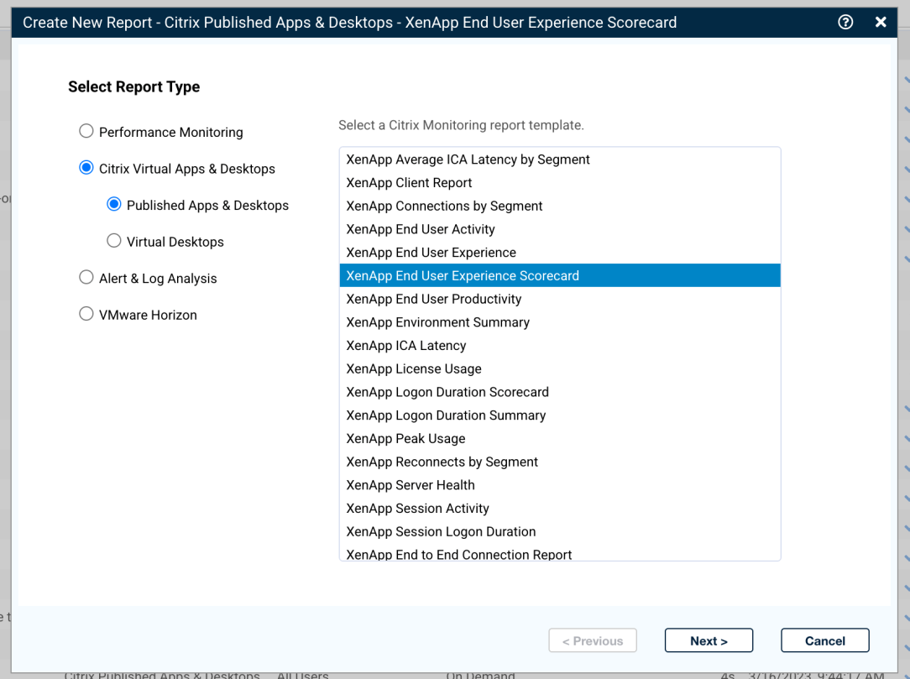
3. For Citrix, select from:
   * + Citrix XenApp End User Experience Scorecard
     + Citrix XenDesktop End User Experience Scorecard
     + Citrix XenApp Logon Duration Scorecard
     + Citrix XenDesktop Logon Duration Scorecard
4. For Horizon, select from:
   * + VMware Horizon BLAST End User Experience Scorecard
5. On the next step, you'll be able to select the columns to display and to adjust the thresholds. You can select to filter the reports by usernames or by Active Directory Organizational Units. In the AD option, you can easily compare different areas of your company to see how they are performing and where you may need to focus on addressing issues.  
   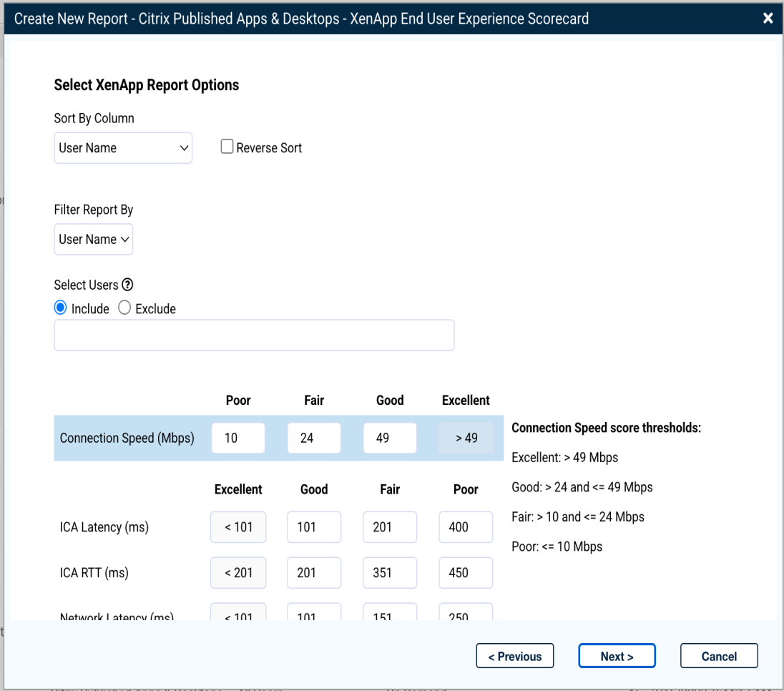
6. Next, select the related devices that represent the group of user sessions you would like to report on. For example, for Citrix published app sessions, select all of the relevant XenApp servers. You can also check **Select all Applicable Devices** and Goliath will automatically select all devices related to the report type.   
   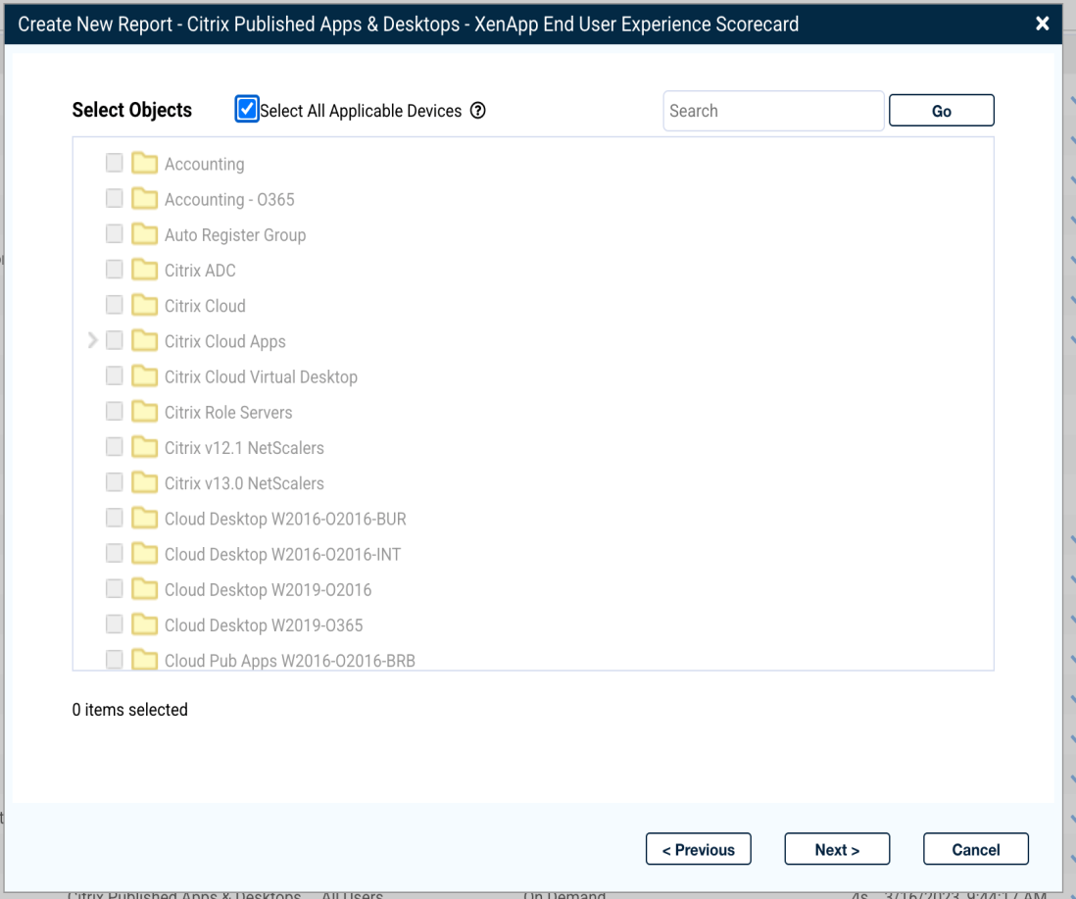
7. At the next step you'll provide a report name and description and optionally assign a report owner.  
   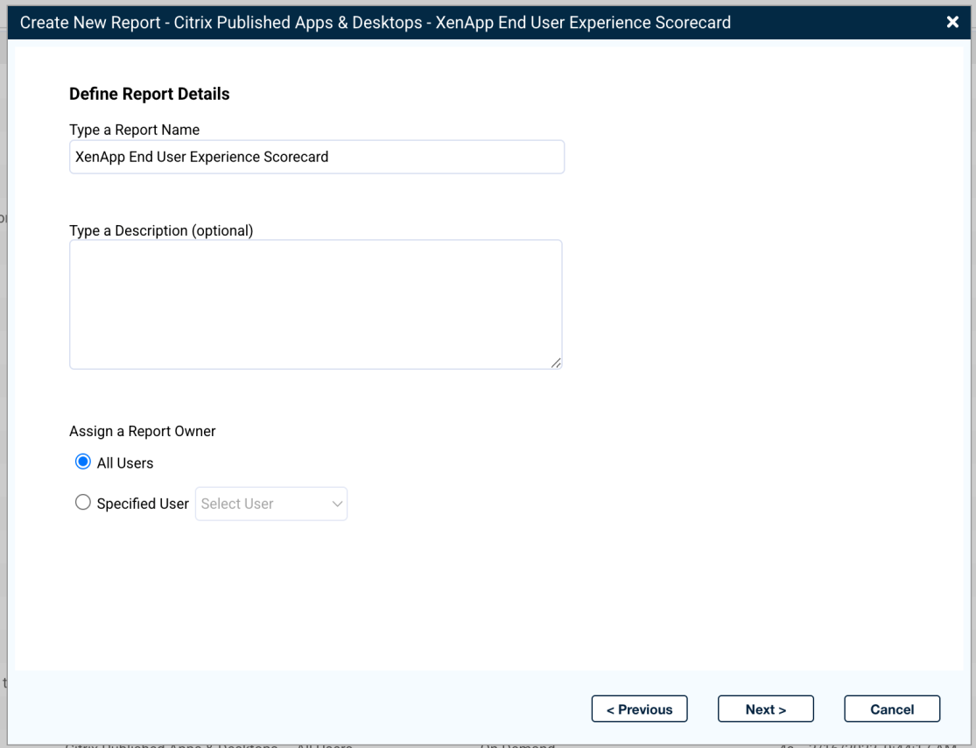
8. Next, setup any sharing options. Enter the email addresses of the users who should receive the report each time it is run. You can also select how to export the report and if you want to store it in a separate location.   
   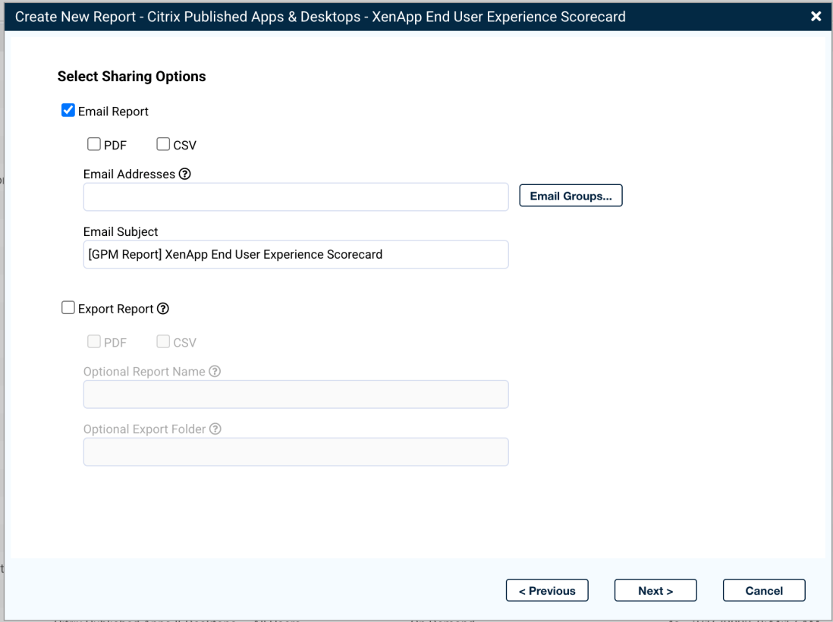
9. Finally, select how often to run the report. Typically, users generate scorecard reports weekly or monthly and provide them to multiple levels within the organization to provide objective data about the overall performance.  
   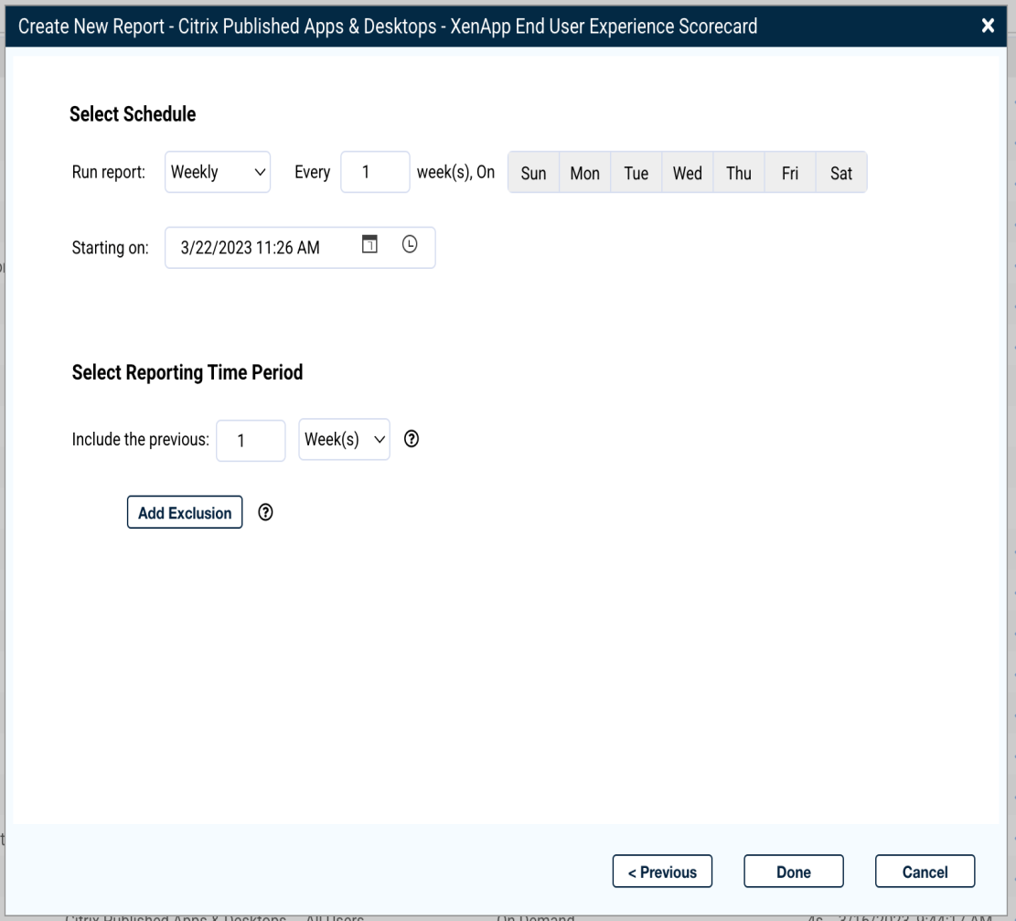

**Scorecard Scoring**

All scores are generated on a scale of 0-100 with scores in the Excellent range for each metric earning the highest value.

The Citrix End User Experience Score categories are displayed below. Each report threshold can be adjusted at Report creation time.

|  |  |
| --- | --- |
| **Metric** | **Description** |
| ICA Round Trip Time (ICA RTT) | Displayed as milliseconds, round trip time between 0ms and 200ms generates an excellent score (100) score. |
| ICA Latency | Displayed as milliseconds, round trip time between 0ms and 100ms generates an excellent score (100). |
| Network Latency | Displayed as milliseconds, round trip time between 0ms and 100ms generates an excellent score (100). |
| Connection Speed | Displayed in Mbps, any connection speed over 50Mbps will generate an excellent score (100). |

The Citrix Logon Duration categories are below.

|  |  |
| --- | --- |
| **Metric** | **Description** |
| Initial Logon (seconds) | Displayed in seconds, excellent logon scores are below 31 seconds by default. |
| Reconnect (seconds) | Displayed in seconds, excellent reconnect scores fall below 11 seconds, be default. |

The Horizon BLAST EUE categories are below.

|  |  |
| --- | --- |
| **Metric** | **Description** |
| Bandwidth Received (Mbps) | Displayed in Mbps, excellent BW received scores start at 7 Mbps. |
| Bandwidth Transmitted (Mbps) | Displayed in Mbps, excellent BW transmitted scores start at 7 Mbps. |
| Estimated Incoming Bandwidth (Mbps) | Displayed in Mbps, excellent estimated BW scores start at 7 Mbps. |
| Network Latency (ms) | Displayed in milliseconds, excellent network latency is measured between 0-100 ms. |
| Packet Loss (ms) | Displayed in milliseconds, excellent packet loss is measured between 0-5 ms. |
| Round Trip Time (ms) | Displayed in milliseconds, excellent RTT is measured between 0-200 ms. |